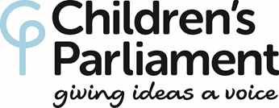
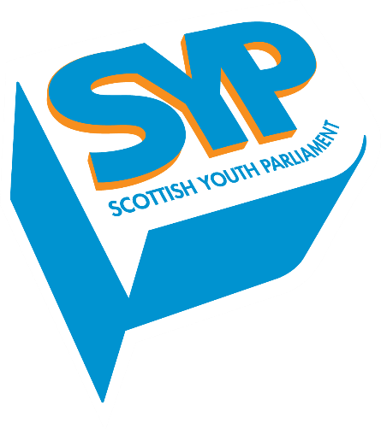

IMMEDIATE RELEASE

Children and young people take part in third historic meeting with the Scottish Cabinet

Representatives from the Children’s Parliament and the Scottish Youth Parliament (SYP) met with the full Scottish Cabinet today, marking the third time that such a historic meeting has taken place.

The Scottish Government has committed to hear directly from children and young people on issues which affect their lives and to collectively agree actions for the coming year in relation to their human rights and wellbeing.

First Minister Nicola Sturgeon said:

“Today’s Cabinet meeting is a great opportunity to further engage with our children and young people at a national level, ensuring they can have their say and be at the heart of decisions which affect them.

“We want Scotland to be the best place for children to grow up. The Children’s Parliament and the Scottish Youth Parliament do great work in helping our children and young people to confidently express their views and have a real influence on the issues that matter most to them.”

The First Minister, Deputy First Minister John Swinney and all Cabinet Ministers welcomed seven Members of the Children’s Parliament (MCPs) and seven Members of the Scottish Youth Parliament (MSYPs) to Bute House today (Tuesday 5th March).

MCPs spoke about their rights being protected, which help them to grow up feeling healthy, happy and safe. Children’s human rights ensure children are recognised as democratic participants today.

MCPs addressed three key issues to the First Minister and her cabinet: poverty, relationships with teachers, and bullying. All are based on the children’s recognition that ‘love’ is the golden thread which winds through the themes.

An MCP, aged 11, said:

“I think more people in Scotland, especially kids, need to know about their rights. If something unfair happens, they need to know what to do.”

MSYPs spoke to Ministers about their national campaign on public transport, All Aboard, a rights-based approach to Adverse Childhood Experiences, their campaign for free music tuition in schools, and about the case for a full ban on “mosquito” Devices. They also restated their call to Ministers to commit to the full incorporation of the UN Convention on the Rights of the Child in the current parliamentary term.

Chair of SYP, Suki Wan MSYP, said:

“We were delighted to have met with the Scottish Cabinet again to discuss ways in which children and young people can be more involved in the decision-making progress. It is great to work with a Government so committed to the meaningful participation of children and young people in decisions that affect them.

“We thank the Scottish Government for their continued support of SYP and look forward to seeing what can be achieved over the course of the next 12 months in the name of children and young people.”

Cathy McCulloch, Co-Director, Children’s Parliament said:

“The Scottish Government is leading the way internationally in demonstrating how it values Scotland’s children and young people. The conversations over these 3 years have made a strong impact on children, young people and Cabinet Ministers. We look forward to working with Ministers and Scottish Government officials over the coming year to ensure that the children’s views and experiences continue to impact thinking, policy and practice.”

ENDS

Notes to editor
- To arrange an interview with Suki Wan MSYP, or for other Scottish Youth Parliament media enquiries, please contact Rachel Ashenden, Communications Officer, rachel.a@syp.org.uk or 0131 524 0819.
- The Scottish Youth Parliament is the democratically elected voice of Scotland’s young people. Their vision for Scotland is of a nation that actively listens to and values the meaningful participation of its children and young people. SYP is grounded in the United Nations Convention on the Rights of the Child, particularly Article 12, which lays out young people’s right to be listened to on the issues that affect them, and for their views to be given weight.
- Children's Parliament is Scotland’s centre of excellence for children’s participation and engagement, working creatively to provide children with opportunities to share their experiences, thoughts and feelings so they can influence life at home, in school and in the community, through change at a local, national and international level. Information and films of previous Children and Young People Cabinet meetings can be found here: https://www.childrensparliament.org.uk/scottish-cabinet-2017/ and here: https://www.childrensparliament.org.uk/cabinet-meeting-2018/
- The annual children and young people’s meeting with the Scottish Cabinet first took place in 2017. At that meeting, First Minister Nicola Sturgeon made a commitment that the meeting would become an annual event in the Scottish political calendar. The second annual meeting took place on Tuesday 6th March 2018. Photos from this year’s event are available at the following link: https://www.flickr.com/photos/26320652@N02

For further Information:
Scottish Youth Parliament
Rachel Ashenden - 0131 557 0452
rachel.a@syp.org.uk

Children’s Parliament

Trisha Emblem – 0131 558 9030
info@childrensparliament.org.uk

